Holly South Series Pinot Noir 2019

Our Holly range is the best we produce. As our reserve range, named after the owners’ daughter, they are our stand out vintage to vintage.

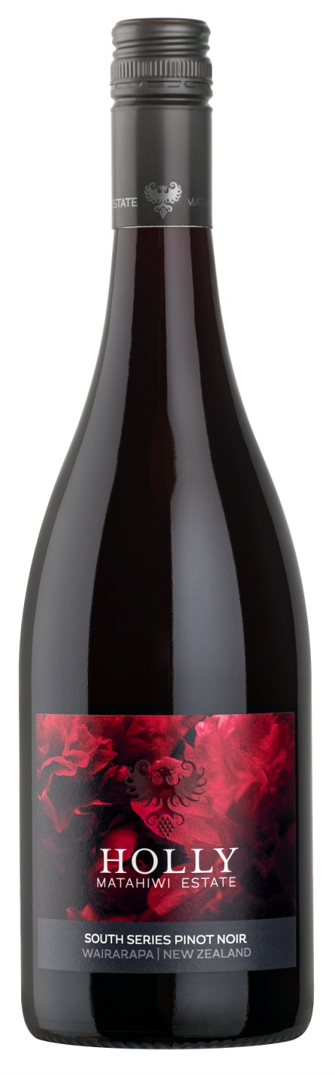
The Matahiwi vineyard is situated on an alluvial boulder ridge in the Masterton district of Wairarapa. With warm free draining soils and the cool dry local climate this is an ideal place to grow Pinot noir.
This wine is harvested from the very best parcels of fruit on our Home Estate, typically from low yielding vines on the lowest vigour areas within the vineyard.
The 2019 Holly South Series Pinot Noir ripples with elegance and finesse reflecting the warm growing season experienced throughout the Wairarapa region. Bold aromatic expressions of wild flower, red berries, spice and herb give way to a fresh palate with generous length and graceful oak.
Vineyard
The vineyard blocks selected for the Holly South Series Pinot Noir receive additional attention during the growing season with a lot of leaf plucking and shoot positioning done by hand to expose the fruit and ensure optimum ripeness.
The Matahiwi Vineyard is planted in several combinations of rootstock and Pinot Noir clones. This wine was made from clones 667, 5, 777, each of which adds their own character and complexity to the final blend.

Winemaking
In the winery, the different batches of fruit were processed separately so that the individual characters could be retained. Further complexity was added by incorporating techniques such as plunging and pumping over to ensure optimum flavour extraction from the skins.
Prior to fermentation the grapes were left to cold soak for 3 days. Different yeast combinations were used, along with wild yeasts, to add even more depth of flavour. The different batches were then left on skins for 21 days before being pressed off into barrel.
This wine also incorporated some whole cluster fermentation, which has lifted the aromatic profile with floral and spice notes. Once in barrel, the wine was aged for 12 months in oak (23% new) before the final blend was put together.

Alcohol: 13.5%
Closure: Screwcap

