

**Matahiwi Estate Sauvignon Blanc 2019**

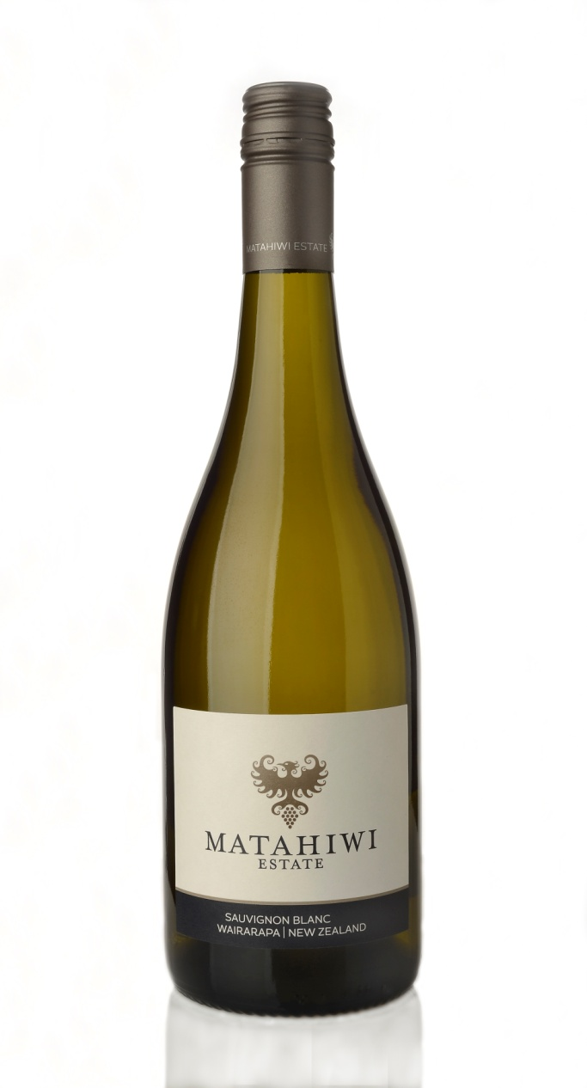

*This vibrant and aromatic wine shows lifted aromas of gooseberry, herbs and citrus, with a sustained mineral and lime finish. At its best now and over the next few years. We suggest pairing it with grilled flounder, or fresh oysters for the complete experience!*

**Vineyard**

The fruit is sourced from 20 hectares of Sauvignon Blanc plantings at our home vineyard at Opaki in the Wairarapa, as well as a tiny portion from Martinborough. Our vineyard is situated on an ancient river terrace, the alluvial soils over Greywacke river stone provide a warm free draining site  growing low vigour vines with naturally balanced yields. We have several different blocks of Sauvignon Blanc defined by clonal and canopy management techniques that give us a range of complex flavours in the grapes.

**Winemaking**

The focus in the winery is to capture the pure fruit flavours that come from the vineyard whilst adding complexity through our winemaking efforts to provide a multi-dimensional wine. The juice was fermented in a mixture of stainless steel tanks with a small portion in older barrels. The pure fresh fruit flavours of the tank fermented portions are complemented by the subtle weight and complexity of the barrel ferments. The wine is further aged over the winter on light lees in tank and barrel to gain added texture before being prepared for bottling.

*Harvest Date: 15th – 19th March, 2019*

*Alcohol: 12.5%*

*BRIX: 18 - 22*